**SWANSEA AREA RATEPAYERS’ ASSOCIATION**

**MINUTES of June 18, 2025**

**Swansea Town Hall**

1. **CALL TO ORDER and DECLARATION OF CONFLICTS OF INTEREST**

***The Meeting of June 18, 2025:******was called to order by Veronica Wynne at 7:25 PM.***

***N.B. This meeting was delayed by one day from the original scheduled date of June 17th.***

***There were no conflicts of interest.***

***Present:*** *Veronica Wynne, Sherrel Dhanpaul, Nick Singh, William Roberts, Janice Kaldor and Claire Czerny*

***Regrets:*** *Sybil Wilkinson,*

***Guests:***

1. **AGENDA AMENDMENTS and APPROVAL**

***June 18, 2025:*** *It was moved by Janice Kaldor and seconded by Sherrel Dhanpaul to approve the amended agenda as follows. The motion was CARRIED.*

1. **MINUTES AMENDMENTS and APPROVAL May 20, 2025**

# EXECUTIVE REPORTS:

* 1. Membership and Report (5 mins) – Nick
  2. Fund Raising & Report (5 mins) – Janice with Executive Support.
  3. Treasurer’s Reports (5 mins) March – Nick
  4. Expenses’ Approvals & Payment – payments and approvals
  5. Riverside Drive Group Sub-Group Report

1. **NEW MEMBERS and GUESTS**

# IMMEDIATE ACTION ITEMS

1. Appeals of OPA 778 and SARG Signing Up as a Participant Status Report - Veronica
2. Fall Out from the Planning and Housing Committee Agenda June 12 & Plan & City Council June 25-26th-
3. Decision of Application for 103 Coe Hill Drive and feasibility of Working with Neighbours & Developer.
4. Go Fund Me and Raising funds to Pay Back the $10 000 we spent on the Bloor West Appeal- All Exec
5. C of Adjustment Application Reports and letter to Councill Perks – Nick/Claire
6. Swansea Village 100th Anniversary Celebration Report Back on First Meeting June 16th – Sherral - f2) Heritage Street Signs
7. Village Playhouse Fundraiser Nov 6th Fee = $700 Report from Meeting with Bill Hammond - Janice
8. Update on New Avenue Zoning Approval and the Integrity of the Swansea Mews Project.
9. Swansea Public School and the Graduation contact and funding discussion and Motion - Bill
10. Bloor West Village Avenue Study Update – Our Study as has been accepted by City Council and in progress, it is not yet affected by the new Zoning 2025
11. C of Adjustment upcoming Applications especially those new in Ellis area- Nick & Claire
12. Sybil Wilkinson – resignation and appreciation of service

Next Meeting: As needed during the July/August Months – Discussion. **Tuesday Sept. 16, 2025**

1. **MINUTES AMENDMENTS and** **APPROVAL**

***June 18, 2025:*** *Deferred.*

May 20, 2025: It was moved by William Roberts and seconded by Sherrel Dhanpaul to approve the April 29, 2025 minutes as circulated. The motion was CARRIED.

April 29, 2025: It was moved by William Roberts and seconded by Sherrel Dhanpaul to approve the March 18, 2025 minutes as amended. The motion was CARRIED.

March 18, 2025: It was moved by William Roberts and seconded by Nick Singh to approve the January 21.2025 minutes as amended. The motion was CARRIED.

January 21, 2025: It was moved by William Roberts and seconded by Janice Kaldor to approve the December 10, 2024 minutes as circulated. The motion was CARRIED.

December 10, 2024: It was moved by Nick Singh and seconded by William Roberts to approve the November 19, 2024 minutes as circulated. The motion was CARRIED.

November 19, 2024: It was moved by William Roberts and seconded by Sherrel Dhanpaul to approve the minutes of October 12, 2024 as amended. The motion was CARRIED.

1. **EXECUTIVE REPORTS**:
   1. **Membership Report**

***June 18, 2025:*** *Nick Singh reported that there were two new memberships this month as well a previous deposit in our bank account for two more. Nick will confirm the membership details and report next meeting.*

May 20, 2025: Nick Singh reported that there were no new members since the last update in March.

April 29, 2025: Deferred

March 18, 2025: Nick Singh reported that since our last meeting in January there have been two new memberships. It was moved by Nick Singh and seconded by William Roberts to approve the membership report. The motion was CARRIED.

January 21, 2025: Nick Singh reported that there was an aggregate of 17 new memberships and renewals for a total of $197 and of the 400 names on our membership list 200 have active e-mail addresses. It was moved by Nick Singh and seconded by William Roberts to approve the Membership Report.

December 10, 2024: Nick Singh provided the following update: he has sent out a membership renewal message to all the e-mails on our membership list and there were seven renewals to date.

November 19, 2024: Nick Singh reported that since the last report there have been 6 membership renewals and one new membership. It was agreed by consensus that Nick Singh should send out a membership renewal message to our current list of past and current members.

November 19, 2024: It was moved by Nick Singh and seconded by William Roberts to accept the Membership Report. The motion was CARRIED.

* 1. **Fund Raising & Report**

***June 18, 2025:*** *Janice Kaldor reported that Bill Hammond has agreed that the Village Players to host our next fundraiser on November 6th at a cost of $700 for the whole theatre.*

***June 18, 2025:*** *It was moved by Janice Kaldor and seconded by Claire Czerny to approve $700 for the Nov. 6, 2025 Village Players preview performance. The motion was CARRIED.*

***June 18, 2025:*** *It was moved by Janice Kaldor and seconded by Claire Czerny to set the ticket price for the Nov. 6, 2025 Village Players preview performance at $30. The motion was CARRIED.*

May 20, 2025: It was moved by William Roberts and seconded by Claire Czerny to recognise that Janice Kaldor and Sherrel Dhanpaul have taken charge of fundraising. The motion was CARRIED.

May 20, 2025: It was agreed by consensus to try to sell out the full theatre at our next Villagers Players fundraiser at an expected cost of $700 for the performance. Sherrel and Janice will arrange it with Village Players Director Bill Hammond. The expected date is in November.

April 29, 2025: The report was deferred. Janice Kaldor and Sherrel Dhanpaul volunteered to take responsibility for fundraising*.*

March 18, 2025: Deferred.

January 21, 2025: Deferred

November 19, 2024: Veronica Wynne reported that the performance of Terror by Gaslight was shared with the Saint Vincent DePaul and that we sold 63 out of our 70 available tickets for a net gain of $1,250 including $25 from the 50/50 draw.

* 1. **Treasurer’s Report**

***June 18, 2025:*** *Nick Singh reported that since the last report in May the second payment to William Roberts for work performed on the 2461 Bloor St. appeal went through our BMO account along with a credit for two memberships leaving a gross balance of $17, 757.01. And in our Paypal account there was a credit of $27.00 for two memberships and a fee of $1.39 leaving a gross amount of $894.21. It was moved by Claire Czerny and seconded by Janice Kaldor to approve the Treasurer’s report as circulated. The motion was CARRIED.*

May 20, 2025: Nick Singh reported that since the last report in March the payment to William Roberts for work on the 2461 Bloor St. appeal went through our BMO account and in our Paypal account there was a $40 donation and $23.72 payment for our website. He also reported that between the two accounts we have $4,400 tagged for the remaining expenses for the 2461 Bloor St. appeal. It was moved by Nick Singh and seconded by Janice Kaldor to approve the Treasurer’s report as circulated. The motion was CARRIED.

April 29, 2025: Deferred

March 18, 2025: Nick Singh circulated the Treasurer’s Report for the period since our last meeting in January. He noted that there was one expense to the STH for our mail box which, with bank fees, amounted to $152.02 while in our Paypal account there were deposits for two memberships which, less fees, came to $30.52. He noted that money from four accounts, the Bloor St Corridor Fund, Gofundme, Donations, and Paypal are available for the 2461Bloor St. OLT Appeal case for a total of $4,400 however an expected invoice from Terry Mills for $800 had not been received as yet. Nick will send Veronica Wynne a copy of Mr. Mills’ letter. It was moved by Nick Singh and seconded by William Roberts to approve the Treasurer’s report as circulated. The motion was CARRIED.

January 21, 2025: Nick Singh circulated three reports for the months of November 2024, December 2024 and January 2025. It was moved by Nick Singh and seconded by William Roberts to approve the three reports as circulated.

December 10, 2024: There was no Treasurer’s Report, however, Nick Singh stated that the $3.94 discrepency reported last month has been resolved and was the result of changes to the way Paypal their displays fees.

November 19, 2024: Nick Singh reported that there were deposits of $605.55 and no expenditures in our BMO account and deposits of $115.00 in our PayPal account however the balance in the PayPal account was inexplicitly short by $3.94. The shortage is under review. It was recommended to remove the donor’s name from the Report.

November 19, 2024: It was moved by Nick Singh and seconded by Sherrel Dhanpaul to approve the report as amended. The motion was CARRIED.

* 1. **Expenses, Approvals & Payment**

***June 18, 2025:*** *There were no expenses.*

May 20, 2025: There were no expenses.

**April 29, 2025:** There were no expenses.

March 18, 2025: There were no expenses.

January 21, 2025: There were no expenses.

December 10, 2024: Veronica Wynne reported that copies of the new Constitution were surprisingly expensive but that they are stamped with the Association`s official seal and ready for distribution.

December 10, 2024: It was moved by William Roberts and seconded by Claire Czerny to reimburse Veronica Wynne $170 for the printing of the Constitution and By-laws of the Association. The motion was CARRIED.

November 19, 2024: It was moved by Nick Singh and seconded by William Roberts to reimburse Janice Kaldor for the cake and decorations used at the AGM as per the provided invoices in the total amount of $61.12. The motion was CARRIED.

* 1. **Riverside Drive Group Sub-Group Report**

***June 18, 2025:*** *No News.*

**May 20, 2025:** No News.

**April 29, 2025:** No News.

March 18, 2025: Veronica Wynne will ask the group contribute to the fund for the 2461 Bloor St. OLT Appeal case.

January 21, 2025: No News.

December 10, 2024:No News.

November 19, 2024: No News.

1. **NEW MEMBERS and GUESTS**

***June 18, 2025:*** *Veronica Wynne reported that Elaine Topping has accepted a new job and is no longer able to join our Board.*

May 20, 2025: No News.

April 29, 2025: Elaine Topping of 22 Southport was invited to attend as a possible future Board Member. Veronica Wynne will follow up with our guest.

January 21, 2025: Aaron Rogers and Mina Di Domenico attended the meeting to discuss the COA application for 71 Kennedy which was deferred at the COA hearing on December 15, 2025. They were alerted to the Association by our submission to the hearing and wanted to meet with us to see if they could contribute to the Association. Mina is an experienced website builder and offered to help us update our site. She recommended we look at the BPW site to see if we like what we see. Aaron’s wife, Trish, is in sales and may be willing to help with membership and fundraising.

December 10, 2024: Chet Czerny

November 19, 2024: Veronica Wynne welcomed Claire Czerny as our new Board Member and Chet Czerny, her husband to our meeting.

1. **IMMEDIATE ACTION ITEMS**
2. **Annual General Membership Meeting**
3. **Expanding Housing Options in Neighbourhoods**
4. **Laneway Suites**
5. **Garden Suites**

November 19, 2024: William Roberts reported that the provincial government is proposing province wide automatic approvals for all Garden Suites. Bill wrote discussing the problems with the proposal.

1. **Multiplexes**

**Major Streets Intensification:**

***June 18, 2025:*** *Veronica Wynne reported that she attended a meeting of the Planning and Housing Committee and it is the Committees intention to ignore the appeal of OPA 778 and implement zoning changes based on OPA 778`s proposed changes to the Avenue Designations throughout the City. The motion that was passed by the Committee calls for the implementation of the OPA 778 changes on a piecemeal basis according to a schedule of areas in the City that will leave Swansea to the end of the schedule. At the meeting Veronica raised the issue of the missing Avenues Map that was supposed to identify which streets have been designated as “Avenues”and which was missing from the OPA778 documents.*

September 17, 2024: William Roberts reported that the Swansea Secondary Plan is protecting the area from consideration for a Major Street designation.

**Site Plan Approval speed-up:**

September 19, 2023: William Roberts reported he attended a public meeting regarding the Province’s proposals to speed-up site plan approvals to assist developers. The proposals are in conflict with the other timelines that are currently mandated such as those in the Complete Application requirements and the zoning approval timelines. Planning recommended that Zoning and OPA`s be in place before Site Plans are filed so that the City would avoid the penalties set out by the Province.

**Mid-Rise Rear Transition Zoning and Guideline Changes:**

January 21, 2025: It was reported by William Roberts that the City is conducting meaningless consultations regarding the proposed Mid-Rise Guidelines and Avenue designations and is pushing through greater heights and densities. CORRA has submitted a letter opposing the changes. It was suggested that SARA object and focus on how the proposed changes affect the Queensway within Swansea.

January 21, 2025: It was moved by William Roberts and seconded by Janice Kaldor to approve Veronica Wynne to write on behalf of SARA in opposition to the proposed changes and for her to attend the meeting on SARA’s behalf. The motion was CARRIED.

December 10, 2024: Veronica Wynne reported that the City`s update can be viewed on the City`s website.

November 19, 2024: William Roberts reported that the City`s proposed Avenue Development Guidelines will be presented in December and will apply to all areas without a completed or in process Avenue Study.

**Official Plan Amendment 660 amendments as per Bills 650 and 651**

Bill 650 and 651give a number of officials the authority to pass and process minor by-laws with a “hold” designation and to use alternate means of providing notices. It is agreed that the two Bills are poorly written and ambiguous. However it is expected that the bills and Amendment will be pushed through.

**Multiplex and Duplex Zoning in Residential Neighbourhood**

May 20, 2025: William Roberts reported that the City has issued a notice for a Public Meeting on June 12th at 9:30 AM to inform of the proposed Zoning By-Law Amendment intended to spur multiplex construction in all neighbourhoods across the city. The text of the proposal should be available by the 23rd of May. We should all read the proposed amendments and make comment. One of the issues is the use of the improper “Duplex” designation for single detached family homes to avoid variances such as the need for FSI compliance.

1. **Official Plan for Toronto**
2. **Swansea Heritage Signs**

***June 18, 2025:*** *William Roberts reported that he needs the digital design file to submit to the Traffic Department for their consideration. Veronica will send what she has to Bill.*

May 20, 2025: It was agreed that Veronica Wynne will provide William Roberts with the necessary information for him to get the new staff at the City`s Transportation Department reactivated in approving our proposal for local street name signs.

September 17, 2024: Veronica Wynne reported that her recent request for an update was answered to the effect that they, the City, is working on it.

1. **South Kingsway Safety**

December 10, 2024: William Roberts reported that Liz Filman has been added to the committee and they are actively working to move this matter forward.

November 19, 2024: William Roberts reported that Liz and Jamie Filman have volunteered to join the committee working on this project. It was moved by William Roberts and seconded by Claire Czerny to add Liz and Jamie Filman to the Committee. The motion was CARRIED.

December 19, 2023: It was moved by Sherrel Dhanpaul and seconded by Janice Kaldor to pursue our proposal, approved at the 2023 AGM, to ask the City, via our Councillor, for traffic lights at South Kingsway and Ormskirk. Our membership will be asked to support the proposal and to provide permission to convey that support and members’ e-mail addresses to the councillor. The motion was CARRIED.

1. **Swansea Town Hall**

***June 18, 2025:*** *Sherrel Dhanpaul reported that she attended the STH 100th Anniversary organising meeting on June 16 and that the date for the celebration is June 13, 2026 and the committee will meet monthly and will be looking at ways to raise money. We are asked to contribute by hosting a booth to highlight SARA.*

***June 18, 2025:*** *It was moved by William Roberts and seconded by Sherrel Dhanpaul to participate in the celebration. The motion was CARRIED.*

May 20, 2025: Veronica Wynne reported that she attended the STH AGM and reported on announcements made by the Councillor regarding the Swansea Mews (See item Z), and the Avenue Study City Consultation (See item X)

May 20, 2025: We have been contacted by the organising committee of the STH 100th anniversary to see if we want to join the Committee. It was moved by William Roberts and seconded by Janice Kaldor to join the committee. The motion was CARRIED.

April 29, 2025: It was agreed to attend the STH may 15th AGM and to set up a table to showcase the Association. Veronica Wynne will contact the STH Director.

March 18, 2025: William Roberts reported that the STH is looking for Board Members and it was agreed that we would post a notice to our website. There are eight meetings per year on the fourth Thursday on each month.

1. **Development Permit System**
2. **Swansea Public School:**

***June 18, 2025:*** *William Roberts reported that he and Sybil Wilkinson are willing to represent SARA at this year’s graduation awards.*

***June 18, 2025:*** *It was moved by Claire Czerny and seconded by Janice Kaldor for William Roberts and Sybil Wilkinson to represent the Association at the graduation and award ceremonies. The motion was CARRIED.*

May 20, 2025: William Roberts reported that he has contacted the school and is waiting for the school to sort out with the Parent Teacher Advisory Council what awards are being presented.

March 18, 2025: There has been no news and William Roberts will contact the school.

September 17, 2024: William Roberts reported that he and Sybil Wilkinson attended the proceedings and all went well. We are still expecting an invoice from the school for the plaques.

1. **Review of the Committee of Adjustment:**

May 20, 2025: Veronica Wynne reported that she attended the City’s May 5th meeting. It was a narrow focus meeting under the control of the Planning Department and concentrated on updating the public about a statement of intent for the procedures of the Committee of Adjustment hearings which was one of the recommendations of two KPMG reports looking at a number of problems with the COA. Included in the statement of intent was a reference to fairness, transparency and being evidence based. Veronica asked what the words were supposed to mean and she was invited to provide clarifications. The period to submit comments is open until June 30th. Veronica will circulate the comment form to the Board for contributions. At the meeting

Veronica noted that issues such as not being able to correct or reply to comments made by the applicant means that errant claims made by the applicant can’t be challenged. There is a suggestion to shorten the hearings by fast tracking the applications that have no objectors. This is already being done and applications with no objectors can currently receive approvals within three minutes. Community member Frank Tall attended the consultation meeting and supported Veronica’s comments.

May 20, 2025: It was moved by William Roberts and seconded by Sherrel Dhanpaul for Veronica to circulate a feedback form for executive comments. The motion was CARRIED.

April 29, 2025: It was moved by William Roberts and seconded by Veronica Wynne for SARA to attend the May 5th City meeting regarding progress of the KPMG changes to the COA. The motion was CARRIED.

It was also reported that the City’s 2024 first quarter review of the KPMG recommended improvements was attended by Veronica Wynne, William Roberts and Nick Singh. The invitees to the review were members of resident associations, and representatives from BUILD. It seems that the review was paired with a new initiative by Planning to hold annual “touch points” with ” public and industry users”. During the presentation there was an opportunity for discussion.

Some of the issues raised were:

Suitability of the Committee Members: It was acknowledged that the appointments are controlled by City Council and the City Clerk and the criteria for hiring is very wide and has no requirement for planning credentials though appointees may have some exposure to planning issues. Training for appointees is scant and superficial.

Process vs. Processing: It was acknowledged that the challenge for the Planning department is to process the 4,000 applications in a timely and cost effective manner and Natural Justice is too expensive and slow “we don’t want people waiting three years for a decision” .

Next steps: Nick Singh will continue to pursue the problem with Mark Strifler at Councillor Perk’s office and Veronica will continue her efforts to provide Kyle Knoeck with ways to simplify the process, improve participation and reinforce participant rights and transparency.

1. **Newsletter:**
2. **Committee of Adjustment Action Plan:**

November 19, 2024: Nick Singh reported that he was able to get a sit-down with the Councillor to determine the Councillor’s willingness to help with reforming the Committee of Adjustment. The takeaway from the meeting is that the Councillor is only interested in managing the public perception. We will have to proceed to the Ombudsman and the Integrity Commissioner.

1. **Membership Activation:**
2. **CORRA**
3. **Toronto Local Appeal Body ( TLAB )**
4. **Expanding Patio Permissions**

April 18, 2023: Nick Singh reported that he had received a message from the City seeking Resident Association participation in a study to decide if the permissions for extra patio space on private property that had been temporarily permitted during the COVID 19 Pandemic should be made permanent. He will forward the message for SARA Board consideration.

1. **Bloor Street Complete Streets Plan**
2. **Night Economy**
3. **Bloor West Festival**
4. **SARA/SARG Monthly Meeting Dates**

September 17, 2024: It was agreed by consensus to set the following dates for our 2025 meetings: the third Tuesday in all months excluding July and August and in December, on the16th of that month. The 2025 AGM will be on October 9th or 16th.

1. **Save Swansea Website**

November 21, 2023: Veronica Wynne reported that she had a request from some of the residents who were involved in the Save Swansea campaign for them to be given control of the Save Swansea website but SARA would continue to host and pay for the site. It was decided by consensus that this would not work as SARA must retain editorial control of its websites.

1. **City of Toronto's Zoning By-law Simplification and Modernization Zoning Amendments**

February 20, 2024: No News*.*

January 18, 2024: There is no news but the link for more information is: <https://www.toronto.ca/legdocs/mmis/2023/ph/bgrd/backgroundfile-240821.pdf>

December 19, 2023: Veronica Wynne reported that she attended, on SARA’s behalf, the meeting for the “City of Toronto's Zoning By-law Simplification and Modernization Zoning Amendments Phase 1 and Phase 2” on November 30th and that all the amendments were passed and two reports accepted. William Roberts reported that Greg Lintern had originally introduced the amendments as intended for RD zones only and then when the RD amendments had passed reintroduced them for all zones on the pretext that it was necessary to have equity in all zones. In this way all zones were up scaled. We expect meetings for 1) Phase 2- Major Streets up scaling and angular plane elimination 2) Phase 3 - the elimination of the Floor Space Index.

1. **City Budget**
2. **Pre-application Consultations**

April 18, 2024: Veronica Wynne reported that community input from Public Meetings is not being included with the reports that are forwarded to Community and City Councils. When forwarded to the Councils for action the agendas include other information from the Public Meetings. It was suggested that where Public meetings invite public comment we should request that providers copy SARA.

February 20, 2024: William Roberts reported that the City is holding meetings regarding a new process for development applications prior to their acceptance as a “completed application”which starts the 90 day clock for approval and we will have to attend the meetings to participate. Nick Singh reported that the changes are driven by Ontario Bill 109 which imposes the timeline. Requiring the public consultations to be completed before the application is deemed complete seems like a good measure to ensure that consultation is done and is included in the application.

1. **Avenue Study City Consultation**

May 20, 2025: Veronica Wynne reported that our City Councillor used the May 15th STH AGM to announce that in April the Planning Department approved a proposal to put three towers on the Swansea Mews site. The approval ignores the Swansea Secondary Plan which does not have the zoning required for the towers and assumes that the Queensway, at Windermere, will be reclassified as an Avenue. The towers were approved without consultation with the communities concerned (Swansea and the previous occupants of the Mews). The proposal seems to be riding on the Avenue Study amendments which did not present the map showing the changes to the Avenue designations during that consultation process and which are currently still missing.

March 18, 2025: Veronica Wynne reported that the City failed to identify all of the intended changes to the public during the consultations. Of particular concern is the map detailing the changes to the Avenue designations. Veronica contacted the Integrity Commissioner who is now looking into it. However, since veronica’s complaint further consultations have been announced.

1. **Bloor Street West Avenue Study**

May 20, 2025: Veronica Wynne reported that there has been no news on the study but she received a notice that the Heritage Conservation District study was cancelled.

March 18, 2025: William Roberts reported that we are still awaiting the release of the report.

January 21, 2025: Veronica Wynne reported that Pavel at the City has said that an update will be released in the first quarter of 2025.

December 10, 2024: Veronica Wynne reported that we have a new contact for the Study.

November 19, 2024: Veronica Wynne reported that the first Public Consultation Meeting for the new Bloor St. W. Avenue Study was well attended by the SARA executive and the purpose for the restart is to increase heights and densities in the study area.

October 15, 2024: William Roberts reported that despite the years of work on the completed Avenue Study for Bloor St. West the City has withheld the resultant by-law amendments and has now mandated a new Avenue Study for the same Bloor St West area. The first public consultation Meeting is today Oct 15th at 7:00 PM at Runnymede United Church, 432 Runnymede Road.

1. **Swansea Mews**

May 20, 2025: Veronica Wynne reported that our City Councillor used the May 15th STH AGM to announce that in April the Planning department approved a proposal to put three towers on the Swansea Mews site and intends to have a mixture of income related rent types such as rent geared to income, rent assisted and market rents. Rents for the 154 returnees will be rent geared to income. In all, the proposal could represent up to 1200 units. All of this was done without consultation with the communities concerned (Swansea and the previous occupants of the Mews). The approval ignores the Swansea Secondary Plan which does not have the zoning required for the towers and assumes that the Queensway, at Windermere, will be reclassified as an Avenue.

November 19, 2024: Veronica Wynne reported that federal funding for the redevelopment of the Swansea Mews has been confirmed.

1. **Gofundme Campaign**

***June 18, 2025:*** *It was agreed by consensus to re-launch the Gofundme appeal to help recoup the costs of the appeal.*

May 20, 2025: It was suggested that we could re-launch the Gofundme appeal to announce the end of the hearings and to ask for help recouping our expenses.

January 21, 2025: It was moved by Janice Kaldor and seconded by Nick Singh to approve veronica Wynne to investigate if Trish, Aaron Rogers’s wife, can assist us with the fundraising. The motion was CARRIED.

December 10, 2024: It was moved by Nick Singh and seconded by Sybil Wilkinson to approve Nick Singh to use our membership list to send out an alert regarding the new 16 Storey proposal for 2461 Bloor St. W. and appeal for support via the Gofundme account and ask for everyone to spread the word. The motion was CARRIED.

November 19, 2024: Nick Singh reported that success with the fund is wholly dependent on us promoting the appeal on all types of social media on which we currently have zero presence. It was discussed that we may be able to get assistance from CORRA member `Randy` and from Bill Hammond at the Village Players. Veronica will contact these people. Nick Singh reported that since he had the credentials for our website he should be able to update it and will investigate resolving this blockage. For updates on our website see item cc) SARA Website.

1. **Official Plan Amendment 528 - Sale of Parks and Green Space**

October 15, 2024: William Roberts reported that the guidelines will be brought in by the end of December.

October 15, 2024: It was moved by William Roberts and seconded by Janice Kaldor to oppose the amendments. The motion was CARRIED.

September 17, 2024: William Roberts reported that the City has proposed an Official Plan amendment to allow for the sale of parkland and green space without the guarantee that it will not pass into private hands. The rationale offered is that sometimes special permissions have to be given for certain types of infrastructure works and selling the land in question will save processing of the permissions. Bill Roberts will write a letter of opposition for October 25th.

September 17, 2024: It was moved by William Roberts and seconded by Janice Kaldor to oppose the Amendment on the grounds that having to do paperwork is not a good reason to sell off public lands and the proposed language is different from the language shown to the public. The motion was CARRIED.

1. **SARA Website**

April 29, 2025: Veronica Wynne reported that she had spoken with John Meijer and that he had reccomended contacting Word Press to address the unsecure problem.

January 21, 2025: It was moved by William Roberts and seconded by Sherrel Dhanpaul to approve Nick Singh to follow up with Mina Di Domenico (See the entry under Guests) to see what assistance Mina can offer regarding our website and to recognised that Sybil Wilkinson’s gift of sponsorship had been approved online and was pending an update of our website, and for Nick Singh will update Sybil on progress with the site. The motion was carried.

December 10, 2024: Sybil Wilkinson reported that her efforts to rejuvenate SARA`s website have produced two suggestions from Bill Hammond (of Village Players theatre group) for finding a webmaster. Veronica Wynne reported that her contact was not able to help.

December 10, 2024: It was moved by Sybil Wilkinson and seconded by Claire Czerny to approve Sybil Wilkinson to explore the hiring of a webmaster and to report to the SARA Board as soon as possible. The motion was CARRIED.

1. **Distribution of SARA’s new Constitution and By-laws**

January 21, 2025: Veronica Wynne reported that copies of the new Constitution have been embossed with the Association’s seal and are ready for distribution to the Board Members. The copies were distributed and Veronica reported that the seal will be returned to the Association’s locker at the STH.

December 10, 2024: Veronica Wynne reported that the copies of the new Constitution and By-Laws have been printed and stamped with the Association`s official seal and will be distributed to the Board Members at the next meeting.

1. **Expanding Retail and Commercial Service Uses Into Neighbourhoods**

December 10, 2024: William Roberts reported that Planning and Housing is presenting to City Council by-law amendments under their EHON project to permit greater retail and commercial service uses in Neighbourhoods. Beaconsfield Village RA circulated their letter of opposition (See Appendix 2) citing a variety of issues and overlooked consequences.

December 10, 2024: It was moved by William Roberts and seconded by Claire Czerny to authorise a letter to be sent to City Council in support of the Beaconsfield letter. The motion was CARRIED.

1. **Amending Allowances for Holiday Retail Openings**

May 20, 2025: No News.

April 29, 2025: It was agreed by consensus that Veronica Wynne will follow up to find out when the report on the consultation meeting will be issued.

March 18, 2025: Veronica Wynne reported that she attended the public consultation for widening the exemptions for holiday openings and the proponents seemed to be primarily concerned about using the exemption to reduce wages and costs. The meeting was not well attended.

1. **Federal All Candidates Debate**

April 29, 2025: It was discussed that in the future we could change the format of the debates and how they are conducted.

March 18, 2025: It was moved by William Roberts and seconded by Sherrel Dhanpaul to hold our federal all candidates debate on April 15th 2025. The motion was CARRIED.

1. **Proposed Housing Plan Outline**

April 29, 2025: In anticipation of our federal government’s efforts to address the affordable housing crisis it was agreed by consensus that Veronica Wynne will draft a suggested Proposed Housing Plan Outline.

1. **City Proposed Restriction on Protests**

April 29, 2025: It was agreed by consensus not to act on this matter.

1. **OPA 778 Appeal**

***June 18, 2025:*** *Veronica Wynne reported that she attended a case management conference (CMC) meeting for the appeal of OPA 778 and was able to have SARG tentatively accepted as a Participant for the appeal. This should be confirmed at the next CMC on July 9, 2025. Our participation will require us to write a full Participant Statement focusing on the Queensway portion of the Swansea Secondary Plan. Veronica will enquire to get a copy of the Draft Procedural Order to discover the full details for executing our responsibilities.*

1. **Resignation of Sybil Wilkinson and Recognition of Service**

***June 18, 2025:*** *It was recognised that Sybil Wilkinson has resigned from the Board but due to our financial situation recognition of her service is deferred.*

**DEVELOPMENT APPLICATIONS (See Appendix 1)**

September 17, 2024: Nick Singh reported that there have been several applications that have been deemed by the building department to be duplexes even though the original application was for a Single Family Dwelling. The result is that these applications evade the by-law for FSI since duplexes are FSI exempt.

**3 Durie St.:**

September 19, 2023: Nick Singh reported that this application was previously refused by the Committee and is nearly identical to the previous application. The design keeps the neighbour in the shade all year and is too massive for the street and hilltop location. Despite presentations from several of the neighbours on August 30th the Committee heard and approved the application. At this hearing Nick Singh was not given an opportunity to participate contrary to the Planning Act and the committee’s rules. This resulted in an apology from the Manager of the Toronto East York COA panel but no remedy. Follow up communications with the Director of the COA, Kyle Knoeck, and Councillor Perk’s office have not produced a remedy and. Nick Singh said he is pursuing the matter.

**4 Beresford Ave.:**

March 19, 2024: Nick Singh reported that this application was approved despite the issues and problems associated with the application.

**7 Armadale Ave.**

March 18, 2025: Nick Singh reported that this Application was heard on February 12, 2025 to alter the existing one-and-a-half-storey detached dwelling by constructing a rear ground floor deck with stairs and hot tub, and a rear yard parking pad. Also, to demolish the rear detached garage and to construct a one-storey ancillary building (for recreation/storage/changeroom uses). The application was approved for all three variances.

**10 Sunnybrook Rd:**

March 18, 2025: Nick Singh reported that the Committee approved all nine variances on this application and broke its own rules by allowing an increase in the amount of landscaping to be heard without the issuance of a new Public Notice.

January 21, 2025:Nick Singh reported that this application is scheduled at the COA on January 29th. The proposal is for ten variances to construct a new three-storey detached dwelling with a front covered porch, a front integral garage, a rear basement walkout, and a rear covered ground floor deck with stairs. Also, to reconstruct the front driveway, abutting Sunnybrook Road.

January 21, 2025: It was moved by William Roberts and seconded by Sherrel Dhanpaul to authorise Nick Singh to oppose the application. The motion was carried.

**10 Waller Ave:**

November 19, 2024: Nick Singh reported that the construction seems to include a reverse driveway which is not permitted. It was recommended that Transportation should be alerted to the possibility.

**11 Brule Cres.:**

December 10, 2024: Nick Singh reported that this application was heard on December 4th. It was to alter the existing two-storey detached dwelling by constructing a new complete second storey addition (partially cantilevered), and a partial third storey addition. Also, to construct a one-storey side (west) ground floor addition, a front porch canopy, and a rear second floor balcony. We did not oppose and it was approved by the COA.

**11 Willard Gardens:**

December 10, 2024: It was reported by Nick Singh that despite the proposed disturbance to the ravine slope the COA approved this application in full.

**June 18, 2024:** Nick Singh reported that this application was back on the schedule. It was moved by William Roberts and seconded by Janice Kaldor to oppose this application. The motion was CARRIED.

**13 Riverside Cres.**

March 18, 2025: Nick Singh reported that the COA heard this application on February 12, 2025 to construct a new two-storey detached dwelling with a front integral garage, a covered front porch and stairs, a rear first level covered deck with stairs, and a swimming pool in the rear yard. The Committee approved all six of the requested variances.

**14 Dacre Cres.**

March 19, 2024: Nick Singh reported that the COA accepted the tiny change offered by the applicant and overturned its previous decision and has now approved this egregious set of variances in full.

**17 Ellis Park Rd.**

September 17, 2024: Nick Singh reported that this application is proposing an oversized building.

September 17, 2024: It was moved by Nick Singh and seconded by William Roberts to oppose this application. The motion was CARRIED.

**17 Sunnybrook Rd.**

***June 18, 2025:*** *Nick Singh reported that this application was approved without conditions.*

May 20, 2025: Nick Singh reported that 17 Sunnybrook Rd is scheduled for a COA hearing on May 21, 2025 to construct a new two-storey detached dwelling with an integral garage, a front covered porch, and a rear ground floor deck. There are five variances for location of roof eaves, double the FSI, two yard setbacks and a platform setback.

May 20, 2025: It was moved by William Roberts and seconded by Claire Czerny to oppose the application. The motion was CARRIED.

**18 Beresford Ave.:**

March 19, 2024: Nick Singh reported that closer examination of the application revealed that the application was in keeping with the four tests and our submission to the committee reflected this and provided reasons for our decision not to oppose the application.

**21 South Kingsway**

December 19, 2023: Nick Singh reported that the COA ignored our presentation and approved all the variances in this application on Nov. 22nd.

**23 Ellis Park Road**

March 18, 2025: Nick Singh reported that the COA heard this application on February 26, 2025 to alter the existing two-storey detached dwelling by constructing a new canopy above the front porch, rear ground floor decks, a rear basement walkout, and a rear second floor balcony. The Committee approved all five of the requested variances.

**24 Durie**

December 19, 2023: Nick Singh reported that the previous owner of the property had been to the Committee of adjustment with a zoning examiner report that missed two variances and that the COA approved that original application with the errors, but, on condition that construction be completed in accordance with the plans. The owner then flipped the property along with the COA approvals to the current owner. The current owner built as per the Committee’s condition to build according to the plans however the inspector halted construction because of the missed variances which by themselves are minor. The application to legalise the construction was approved on Dec. 6th.

**26 Ostend Ave.**

December 19, 2023: Nick Singh reported that he presented a very detailed opposition to this application and it was ignored by the Committee and approved on Nov. 29th with the justification that the area was known to one of the committee members to be “eclectic”.

**28 Grenadier Heights**

September 17, 2024: Nick Singh reported that this application seeks a precedent setting third floor platform.

September 17, 2024: It was moved by Nick Singh and seconded by William Roberts to oppose this application. The motion was CARRIED.

**29 Grenadier Heights**

March 18, 2025: Nick Singh reported that The COA heard this application on February 12, 2025 to alter the existing two-storey detached dwelling by constructing second and third storey additions. The Committee approved the single variances to increase the height of the rear wall from 7.5m to 9.03m.

**33 Kennedy Ave.**

January 21, 2025: Nick Singh reported that this application to alter the existing two-storey detached dwelling by constructing a front covered porch, a rear two-storey addition, a third storey addition, a rear ground floor covered deck, and rear second and third storey balconies and also, to construct a new one-storey ancillary building (detached garage), in the rear yard of the property was heard on January 15th and was approved by the COA. Nick Singh represented SARA/SARG at the hearing and opposed it as it was not minor and did not pass the test for the Official Plan.

January 21, 2025: It was moved by William Roberts and seconded by Sherrel Dhanpaul to recognise Nick Singh’s opposition to the application. The motion was carried.

**34 Southport**

November 19, 2024: Veronica Wynne reported that the start of construction has been postponed to from January 2025 to January 2026.

**34 Morningside**

September 17, 2024: William Roberts reported that construction has begun.

March 21, 2023: Continue to Monitor until September 19, 2024

**38 Ellis**

***June 18, 2025:*** *Nick Singh reported that the Committee approved this application.*

May 20, 2025: Nick Singh reported that38 Ellis Ave. is scheduled for May 2,2025and is proposing to alter the existing two-storey detached dwelling by constructing a complete third storey addition and a partial fourth storey addition. Also, to construct a front third storey balcony with a canopy, and a front fourth storey terrace. There are nine variances including two for landscaping, one yard setbacks, extra height, double the FSI, extra wide driveway and two platform variances.

May 20, 2025: It was moved by William Roberts and seconded by Claire Czerny to oppose the application. The motion was CARRIED.

**40 Deforest Rd.:**

November 19, 2024: Nick Singh reported that this application was heard by the Committee of Adjustment on October 16, 2024.This application sought to increase the previous COA approval for FSI to 0.84 in a 0.06 zone and if approved would be at odds with 87% of the immediate neighbourhood. The applicant provided obviously incorrect information and the Committee approved the application.

**41 Armadale Ave.**

March 19, 2024: The application for this address is scheduled for a hearing at the COA. Regrettably our current workload outweighs our ability to present a proper objection at the hearing.

**45 Armadale:**

December 10, 2024: Nick Singh reported that through discussions the applicant and SARA had reached an agreement for conditions that would prevent abuse of the as-of-right permissions under the By-Laws and address our concerns and opposition to the variances. Despite the applicants testimony agreeing to the conditions, the COA said it was unable to impose any conditions and approved the application in full.

June 18, 2024: Nick Singh reported that the plans for this proposed Garden Suite supposed that there a substantial foundation under the existing garage that would enable retaining the current walls. However this was unlikely as it would be atypical. There were several other questionable issues.

**60 Mayfield Ave.:**

November 19, 2024: Nick Singh reported that this application was heard by the Committee of Adjustment on October 16, 2024. This application sought to place an oversized balcony in an Immediate Neighbourhood where there were no balconies whatsoever making it zero percent for the balcony to be in support of the neighbourhood character. The Committee approved the application thereby setting a new precedent.

**71 Kennedy Ave.**

January 21, 2025: The hearing for this application was on January 15th, 2925.Nick Singh represented SARA/SARG. The applicant requested another deferral. Nick Singh was asked for SARA’s position and said that given that the agent had indicated that they wanted to address all parties and issues he assumed that SARA would be involved and agreed to the deferral.

Mr. Aaron Rogers also agreed as did the representative of 10 & 12 Deforest and Mina Di Domenico.

The deferral was approved*.*

January 21, 2025: It was moved by William Roberts and seconded by Sherrel Dhanpaul to recognise Nick Singh’s opposition to the application. The motion was carried.

**76 Ellis Park Rd.**

December 19, 2023: Nick Singh reported that our arguments were ignored by the COA and this oversized building was approved for every variance requested.

**80 Ellis Park Rd.**

***June 18, 2025:*** *Nick Singh reported that 80 Ellis Park Rd. was scheduled for a hearing on June 18, 2025 to construct a new three-storey detached dwelling with a front integral garage, a front terrace with stairs, a front second storey green roof canopy, a front third storey terrace, a rear walkout basement, a rear first floor deck with an integral hot tub and stairs, and a rear third storey balcony. There will be one secondary suited within the basement. There were 14Variances: six variances for setbacks for the balconies plus driveway and stairs, building height, wall height, length and FY Setback.*

*A letter in the file from the applicant to the Transportation Department revealed that the variances had been reduced from 14 to 7. Our letter detailed problems with this change from a public participant objective pointing out that without knowing which variances were still applicable to the hearing we were unable to ascertain if we objected or not and the hearing would be something of an ambush. At the start of the hearing the applicant asked for a deferral which was granted by the Committee.*

**85 Morningside**

***June 18, 2025:*** *Nick Singh reported that 85 Morningside Ave. was scheduled for a COA hearing on June 11, 2025 to alter the existing two-storey detached dwelling by removing the rear deck and constructing a rear two-storey addition with stairs. Also, to enclose the front porch (for habitable space) and to construct stairs*. *There were four variances: FY Setback, Building Depth, FSI and SY setback. The four variances were minor so we wrote reminding the Committee to apply the four tests.*

**103 Coe Hill**

***June 18, 2025:*** *Nick Singh reported that for the first time in at least three years the Committee of Adjustment refused an application in Swansea for 103 Coe Hill. In the aftermath the residents reached out to SARA for guidance and we recommended reaching out to the Developer. All parties have agreed to sit down but we are having trouble finding a date and one meeting was canceled.*

May 20, 2025: Nick Singh reported that 103 Coe Hill is scheduled for a COA hearing on May 21, 2025 to alter the existing three-storey apartment building (containing three residential dwelling units) by constructing a front three-storey addition. Also, to construct front and rear ancillary buildings for waste storage and 6 bicycle parking spaces, and a front ancillary outdoor area for 5 parking spaces. There will be a total of 13 residential dwelling units on this lot. There are nine variances, three for landscaping, a reduction of the front setback from 40.5m to 17.46m, two for an ancillary building including a setback reduction from 54.15m to 0.0m, building depth from 17m to 30.41m, and reduced bicycle facilities.

May 20, 2025: It was moved by William Roberts and seconded by Claire Czerny to oppose the application. The motion was CARRIED*.*

**103 Durie St.**

December 19, 2023: Nick Singh reported that this oversized building was approved on Dec. 6 despite our arguments and the opposition presentation by the immediate neighbour.

**120 Morningside Ave.**

May 20, 2025: Claire Czerny reported that a COA hearing was held on April 23, 2025 for 120 Morningside Ave. to construct a new two-and-one-half-storey detached dwelling with an integral garage, a covered front porch with stairs, a rear basement covered patio (at-grade), a rear first level terrace with stairs and a canopy (semi-covered), a rear second level covered balcony, and a rear third level covered terrace (above the second floor). Also, to reconstruct/relocate the front yard driveway. There were nine variances, one for front yard setback, two for platforms, two for extra height, length, depth entrance height, and minimum driveway width. Claire and Chester Czerny attended and pointed out the improper posting of the on-property notice, the removal of trees and intense alterations to the landscaping and the installation of a pool. Also one of the committee members participated from home. The Committee ignored everything. and all variances were approved. As work and re-landscaping has already begun work should be monitored by the City so Claire will continue to keep the City updated with photos sent to Urban forestry and the Councillor’s office..

May 20, 2025: It was moved by William Roberts and seconded by Claire Czerny to approve our opposition to the application. The motion was CARRIED.

**160 Morningside Ave.:**

September 17, 2024: Nick Singh reported that this application is a return trip to the COA this time asking for more FSI than the first time based on claims that are not supported by the Plans submitted.

**232 Willard Ave.: Monitor**

October 17, 2023: October 17, 2023: It was agreed by consensus to monitor the construction until 2024.

September 19, 2023: Nick Singh reported that the developer did not resubmit the application to the COA. However, construction began over the summer and its progress is being monitored.

**236 South Kingsway**

March 19, 2024: The application for this address is scheduled for a hearing at the COA. Regrettably our current workload outweighs our ability to present a proper objection at the hearing.

**240 Riverside Cres.**

November 19, 2024: Nick Singh reported that this application was heard by the Committee of Adjustment on October 16, 2024. This application was for a deck in a TRCA controlled area and the TRCA approved it so we did not oppose the application.

**307 Riverside Drive: Monitor**

September 17, 2024: William Roberts reported that this matter was appealed to the TLAB and has now been approved.

**1978 Lake Shore Blvd. Monitor**

January 18, 2024: It was agreed by consensus continue to monitor this item

**2453-2469 Bloor St West: This application is for a 12 storey condo tower**

**May 20, 2025:** It was moved by Sherrel Dhanpaul and seconded by Claire Czerny to pay William Roberts $2,362.38, inclusive of all taxes and fees for his work on the 2461 Bloor St Appeal. The motion was CARRIED.

**May 20, 2025:** It was moved by Janice Kaldor and seconded by Claire Czerny to pay Terry Mills a total of $7,000, inclusive of the previous payment of $1977.50 (See Oct. 2024 Treasurer`s Report) and all taxes and fees for his work on the 2461 Bloor St Appeal. The motion was CARRIED.

March 18, 2025: William Roberts reported that he and Veronica Wynne will be meeting with the City to clarify the case and positions.

March 18, 2025: N. B. On March 17, 2025 It was moved on line by Nick Singh and seconded by Sybil Wilkinson that SARG retain William Roberts as Legal Counsel on the 5 day Appeal of 2453-2469 Bloor St. W. at the fee of $3,000 + HST. William Roberts was not included in the online discussion did not participate in the vote. The motion was carried.

January 21, 2025: It was reported by Veronica Wynne that Terry Mills will be represent SARA at the OLT hearing tomorrow Jan 22nd which we expect will focus on narrowing the issues. Veronica spoke with Pavel at the City to highlight the importance of recognising the protections recommended by recent studies and that these protections were supported by Melanie the previous City representative for the appeal.

December 10, 2024: Veronica Wynne reported that she spoke with the City`s Lawyer and Planner and learned that the City`s planning report regarding the developer`s new 16 storey proposal will be available on December 17th. The next OLT timeline is January 8, 2025at which time we must provide a list of our witnesses. Given that our Planner has been hospitalised Veronica spoke to Professor John Meligrana who has agreed to look at the proposal and possibly step in as our planner if necessary.

December 10, 2024: It was moved by William Roberts and seconded by Claire Czerny to write to the City and copy the Councillor asking them to maintain the currently approved 10 storeys. The motion was CARRIED.

December 10, 2024: It was moved by William Roberts and seconded by Janice Kaldor to provide John Meligrana with the necessary documents and to approve Prof. Meligrana as our Planner for the OLT hearing if Terry Mills is not able to represent the Association and if Prof. Meligrana accepts the position. The motion was CARRIED.

December 10, 2024: N.B. William Roberts was asked to leave the meeting during discussions related to the following motion including the proposal and voting. He removed himself until the matter was resolved and he was recalled to the meeting.

December 10, 2024: It was moved by Sybil Wilkinson and seconded by Claire Czerny to hire William Roberts as our legal advisor to our Planner for this case, OLT appeal of 2461 Bloor St. W., for the sum of $500. The motion was CARRIED.

November 19, 2024: Veronica Wynne reported that the SARA was recognised as a Party to the OLT appeal sheltering under the City`s Party status, with the attendant but limited rights. We are able to fully participate in the OLT proceedings but we are not able to block the settlement of any or all matters under appeal should the City and Developer decides to settle them. The developer appears to be nervous about our participation and has been trying to limit our participation. We have complied with the OLT`s procedural order to produce an issues list which was done by our Professional Planner with a view to the City`s issues list. The City complained that we had used their list and the Developer objected to our presence under the City`s Party status, both to no avail. Following the settlement of those objections the Developer asked SARA to submit to the OLT a new development proposal for the site on their behalf. The new plan increases the number of floors to 16 plus the amenity space. SARA refused as that would be in conflict with our interests and as a non-appellant party it falls to the City to agree or not to the change in the matter at issues before the OLT. The new plan has been submitted to the OLT but we do not the City`s response. The next dates at the OLT are Jan 8, 2025 to exchange witness lists and Jan 22 to consolidate the issues list.

November 19, 2024: It was moved by William Roberts and seconded by Sherrel Dhanpaul to approve Veronica Wynne to contact the City`s lawyer to sort out our issues lists and which development plan we will be dealing with. The motion was CARRIED.

**MONITOR ITEMS**

**House Keeping:**

1. **Insurance Policy**

December 19, 2023: Nick Singh reported that the insurance policy has been renewed for $1,361.

1. **Annual General Membership Meeting**
2. **Board of Directors Recruitment**

November 19, 2024: Veronica Wynne reported that Nicole Wineman has reconsidered her position as a Director because of her personal schedule and has expressed an intention to resign. There is also a difficulty with Elizabeth Tsihlias`s inability to attend meetings and remain a Director. Veronica will contact these members and confirm their intentions.

1. **Constitution Update**
2. **Annual Booking of Space for Meetings**
3. **Membership Committee**
4. **Swansea Town Hall Garage Sale**
5. **BIA Sidewalk Sale**
6. **YIMBY (Yes In My Back Yard)**
7. **Swansea Public School Graduation Awards**
8. **Road Closures: Ukrainian Festival**

**Local Interest:**

1. **Swansea Traffic Study**

**Development Applications:**

1. **Joyco Gas Station Heritage Building**
2. **21 Verbena**
3. **2500 Bloor Street W. (Tridel) Traffic Study**
4. **Park Lawn / Lake Shore Area Transportation Master Plan**
5. **19 Harcroft / 2117 Bloor St.**

**Adjournment:** *The meeting was adjourned at 9:00 PM.*

**Next Meeting:** Next Meeting: **Tuesday Sept. 16, 2025** or as needed during July and August.

**Appendix One:** 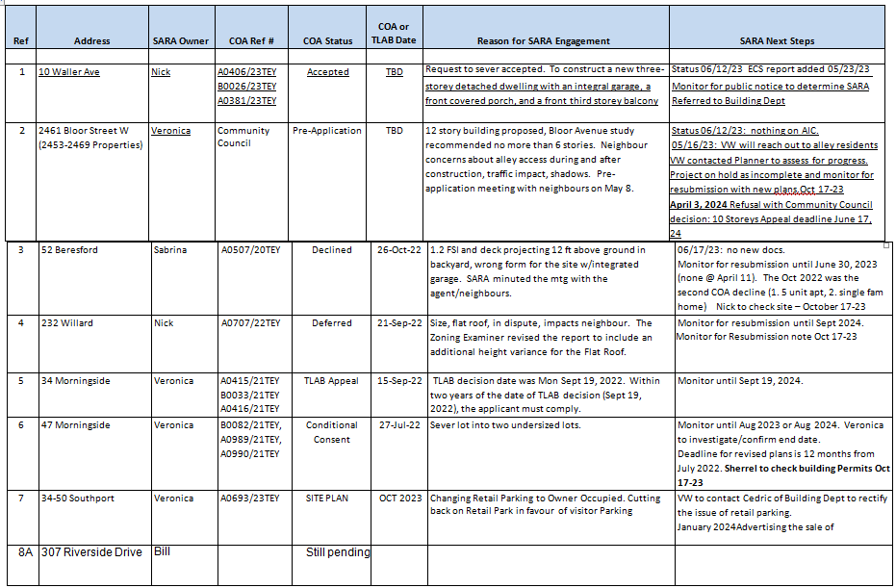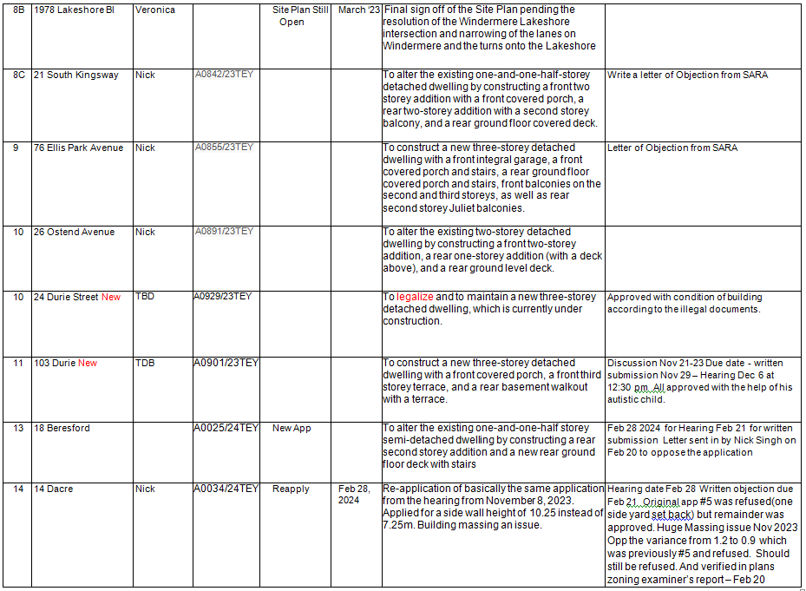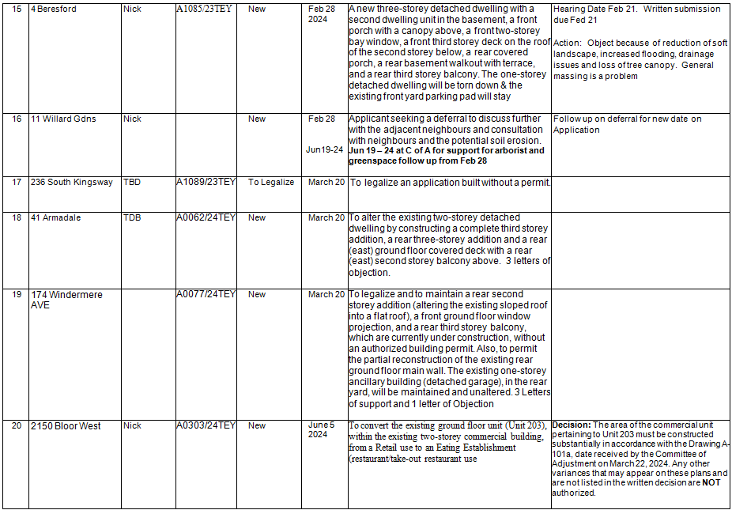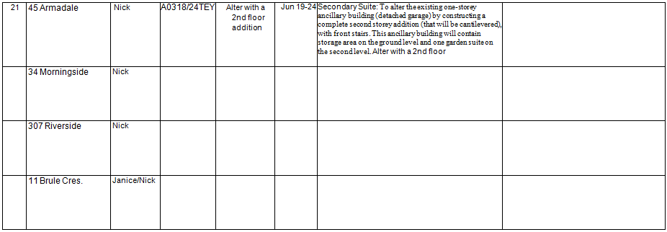

|  |  |  |  |  |  |  |  |
| --- | --- | --- | --- | --- | --- | --- | --- |
|  | 71 Kennedy |  |  |  |  |  |  |

Appendix 2: Beaconsfield Village RA Letter to City Council Re; Expanding Retail and services into Neighbourhoods

December 4, 2024

Planning and Housing Committee

10th Floor, West Tower, City Hall

100 Queen Street West

Toronto, ON M5H 2N2

SUBJECT: Item 2024.PH17.2 - Expanding Housing Options in Neighbourhoods

Neighbourhood Retail and Services Study Phase Two Final Report - Request to Amend

the Zoning By-law to facilitate small-scale retail, service, office, and house

occupation users within Neighbourhoods

Dear Planning and Housing Committee,

The Beaconsfield Village Residents Association (BVRA) in Ward 9 is in favor of the

EHON program which seeks to increase the density of residential housing. We also

support appropriate, limited commercial development inside residential neighbourhoods.

However, our members have concerns with the proposed by-law amendments because

there are insufficient guardrails to prevent adverse impacts on residents of inner

neighbourhoods.

Below are the reasons for our concerns, followed by our recommendations for effective

guardrails.

(a) Under these amendments, there is nothing to stop a bar with a patio from

opening on any corner property or any property next to a school or a park or on a

crescent or bend. Bars with patios are inherently disruptive to inner

neighbourhoods because drinkers tend to create disturbances such as noise,

litter, etc.

(b) Liquor licenses are granted by the province via the AGCO and the City is

powerless to prevent them. In fact, licenses to sell beer and wine have already

been granted to convenience stores. With the proposed addition of patio plus

indoor seating such stores could become de facto bars since patrons can

purchase their wine/beer and consume it on site.

(c) The proposed amendments will not prevent cannabis stores in inner

neighbourhoods as the AGCO does not allow municipalities to treat cannabis

shops differently from other retail stores through licensing, location, etc. (The

only restriction is that a cannabis shop can’t be located within 150 meters of a

school.)

(d) The proposed amendments do not prevent vape shops or cigarette sales from

opening on any corner property and besides schools and parks. Not to mention

the potential for any other kind of business that could result in adverse impacts

such as pop-up stores or retail stores that rely on deliveries both of which

generate outside traffic and delivery drivers that take away parking and jam the

streets of residential inner neighbourhoods areas.

(e) On May 9, 2024 the Planning and Housing Committee directed the Chief Planner

and Executive Director, City Planning, to consult with residents’ associations.

Despite this there are no reported meetings with resident associations in the

Planning report.

The BVRA sent an email with our concerns to the Planning Department. Planner

Candance Safonovs promised to respond and to update the web site with same.

That never happened. Furthermore, the head of the BVRA requested a meeting

with Candace, Michael Noble and Kyle Knoek. We never heard back. Therefore,

it’s clear the concerns of residents have not been taken into account and are not

discussed in the Planning report in any meaningful way.

(f) The information sessions during the summer were sparsely attended. We

attended the one on June 11, 2024, and there were about a dozen people there.

Planner Candance Safonovs acknowledged that attendance at the other

sessions was poor.

(g) The survey that was run by City Planners is not a representation of Toronto

residents as only around 1000 people in a city of millions completed the survey.

The respondents were self-selected and not scientifically polled so their views

are random and anecdotal and therefore not representative of what the public

thinks of the changes (less than 0.039% of Toronto residents responded). The

survey also did not explain that bars and cannabis stores are allowed under the

proposal.

In addition, it appears the survey and related communications were only offered

in English, thereby excluding large segments of our multicultural city. Also, since

the survey was digital it may have excluded the elderly who are not tech savvy

enough to respond. The vast majority of Toronto residents are not aware of the

full ramifications of these proposed changes.

(h) Early drafts of the proposed changes at least had a requirement for “hot drinks”

which would be a small measure to try and prevent the province from issuing a

liquor license —but even that has been taken out.

(i) Earlier drafts also called for only “low-risk or pre-packaged, ready-to-eat food

items” to be sold in inner neighbourhoods. That’s been replaced with any food

prepared off site, which is unclear and open to many possibilities. Does it mean

that any kind of food prepared off site can be reheated in the store? Under this

definition a business would be able to cater in meals from another location which

has the same effect as a full-service restaurant which brings crowds, garbage,

traffic and noise to quiet neighbourhoods which are not designed for commercial

use.

(j) An eating establishment (restaurant) is permitted on 580 square feet of the 1200

square feet allowed for a retail store. Nearly 600 square feet is sufficiently large

enough to run a high-volume eatery/bar—think of a fast-food location which has

a small footprint but high traffic. In addition, in practical terms this is not possible

to measure and enforce. For example, once a space is being used as a

restaurant/bar the counter will serve as both retail and service and people will

consume on seating throughout.

(k) In practical terms there is no way to enforce any of these requirements. For

example, once a patio is allowed, the onus will be on neighbours to call by-law

enforcement if the patio should expand beyond the allotted square meters. Or if a

kitchen is installed and food is prepared on site, etc. Noise complaints are no

longer enforced by the police and by-law officers don’t work on weekends. It’s a

long process to complain and nothing can be done at the time of the offense.

(l) The City has previously established guidelines for patios near residential areas in

a 2009 study of Ossington and Queen St. West. The study concluded that a tenmeter

setback and fencing were insufficient to protect residents from patio

disturbances such as noise, privacy, overlook, lighting, and cigarette smoke. The

study highlighted that while city noise by-laws can address loud music, it cannot

mitigate patron noise and other disturbances from patios.

Following this study the setback was increased by the City to 30 meters. By

comparison the proposed bylaw is asking for only a one-meter setback. Keep in

mind that many corner properties are closely surrounded by residential family

homes on all sides, well within the thirty-meter setback recommendation.

(m) It’s worth noting that the proposal will constitute the most radical change to

residential zoning in Toronto’s history. We’ve had residential zoning for almost

70 years (since 1959) which separates quiet family streets from the noise,

garbage and traffic of commercial zones. This change will irrevocably put an end

to that residential zoning. The changes are permanent and irreversible due to

legal non-conforming rights. Once businesses are established on residential

streets, other nearby properties will have the precedent to apply for commercial

use to the Committee of Adjustment and the permitted small retail stores can

apply to expand their footprints.

(n) Our concerns are grounded in real world experiences that highlight how zoning

bylaws and loopholes can negatively impact residential neighbourhoods.

• A former convenience store was converted to a coffee shop, which we didn’t

object to. But once the coffee shop was established, the owner applied for a

liquor license. Despite strong objections from the councilor and community,

including a petition signed by 400 people and a year-long campaign, the

liquor license was granted. Following the liquor license, the establishment

brought noise, traffic, and social disruptions to the neighbourhood.

• A real estate developer bought a former convenience store on a residential

corner and tried to put in a branded chain bar. Only the current zoning laws

prevented that from happening.

• An online retailer operates a location in a 1,000-square-foot residential

property in downtown Toronto. Classified as a retail store the site functions

primarily as a warehouse for deliveries, causing noise, traffic, and disruptions

in the neighbourhood. Operating from 1:00 PM to 12:00 AM with constant

deliveries, the business continues to operate despite complaints, as its

license has no restrictions on delivery operations.

These examples highlight the need to revise and clarify zoning by-laws to

prevent similar misuses in the future and to better protect the character and

livability of residential neighbourhoods.

Requested changes

BVRA is in favor of the EHON program which seeks to increase the density of

residential housing. However, this last phase of the program stands in contradiction to

that goal because it will allow existing residential properties to be turned into

commercial businesses. This may simultaneously reduce the supply of housing while

potentially having adverse impacts on residents. A lose-lose proposition.

If the City is going to upend decades of Residential zoning, then it is incumbent on

officials to make sure that residents are protected from adverse impacts.

Other cities such as Vancouver have allowed small scale grocery stores to open on

Residential streets but the category is strictly defined and may not sell alcohol or have a

patio. Feedback gathered by the planning department highlighted an interest in two

primary uses: local convenience stores and coffee shops. So there is no logical reason

why the City of Toronto cannot similarly clearly define what is allowed on inner

neighbourhood streets rather than allowing any kind of store, many of which do not

require licenses.

A clear definition would be a reasonable safeguard for this by-law when it comes to

commercial development in inner neighbourhoods.

In addition, patios pose a high risk of adverse impacts in inner neighbourhoods for

obvious reasons.

As it stands, the proposed by-law would allow patios on residential streets as a blanket

right. This is a by-law that will affect tens of thousands of streets and millions of

Torontonians. It seems unreasonable and unfair to foist patios on neighbours without

consulting them first. The Planning report says that Planners want to allow for

development to take place according to specific local needs, but by pre-allowing patios

the needs of local residents are being overridden.

Therefore, before patios are allowed, we think a reasonable safeguard would be to poll

all the neighbours within 120 meters of a proposed patio. If there are no objections a

patio could proceed; if there is an objection then the property owner could apply to the

Committee of Adjustment.

This was the City’s standard prior to the Café TO program. This process would allow

residents to participate in decisions that directly impact their quality of life. It is a timetested,

fair, and equitable approach that fosters balanced development while

considering the interests of all stakeholders.

Lastly, the proposed by-law treats all neighbourhoods as if they are the same.

Downtown neighbourhoods such as ours are situated within walking distance of major

commercial streets. For such neighbourhoods adding corner retail is not needed.

The Planning report acknowledges that retail belongs on major streets but claims that

some inner-neighbourhood streets are more than 500 meters from major streets and

therefore too far to walk. If that’s the case then why allow retail on neighbourhood

streets that are within walking distance of major streets? The by-law should exempt

inner neighbhouhood properties it they are less than 500 meters away from a large

commercial street.

If existing commercial infrastructure is within 500 meters of a proposed new store,

residents already have nearby walkable options, reducing the possibility that much

needed housing is replaced by businesses.

Such a limitation would also prevent developers from exploiting the proposed

amendment as a loophole to establish businesses in residential areas at lower costs,

drawing customers from nearby commercial strips.

To summarize:

1. The proposed by-law changes fail to protect residents from adverse impacts in

inner neighbourhoods.

2. The by-law should contain a precise definition of what kind of business is allowed

in inner neighbourhoods, and alcohol should not be permitted to be consumed on

site.

1. The by-law should not allow patios unless the neighbours agree to it.

4. There should be no permitted commercial development if a given residential

property is within 500 meters of a major street.

We hope the committee will consider these objections seriously and send the proposal

back to Planning for further changes before allowing it to proceed to a full council vote.

Given the permanent and radical nature of these changes, real safeguards for Toronto

residents are essential and the by-law should contain them. As it stands the proposed

by-law will likely lead to future problems for residents and set the stage for needless

confrontations.

Thank you,

Nicole Tataj on behalf of Beaconsfield Village Residents Association